Felix Situ Engl 149

October 15, 2017

Robotics in Virtual Reality

**What is Virtual Reality (VR)?**

VR is an advanced technology that simulates a realistic world using computer graphics that the user can directly interact with. As the audience uses it, they feel immersed inside the simulated world and treat it similarly to the real world. VR tracks the human’s physical body visually and kinesthetically to creates outputs accordingly. It captures the human senses and aims to simulate them to make users feel physically inside this virtual world. Virtual Reality sets itself apart from other current media platforms with its “physical immersion,” while television, radios, books, and video games offer a mental immersion (Franca, Soares 54).

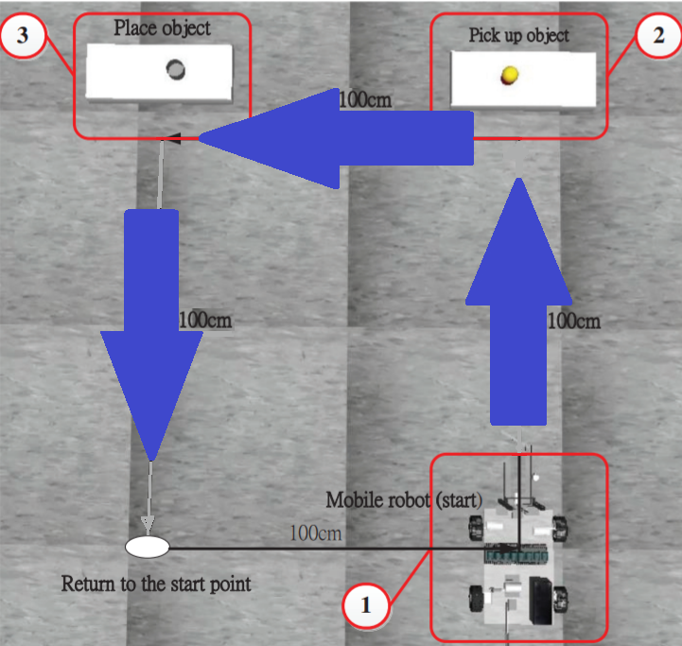**What is Robotics in Virtual Reality?**

Chin-Shan Chen and Ching-Wen Lui from the National Pingtung University of Science and Technology proposed the testing of robotic experiments using VR. Their proposal aims to simulate a real-life robotics experiment. They will operate a mobile robot in virtual reality via wireless communications to pick up an item at a spot, place it at another area, and return to another location. Everything that happens in VR will exactly match with the real experiment. Virtual Reality offers “aided instruction, training, and simulation of manufacturing processes” without abandoning much of the real and original scenes (Chen, Lui 1). If successful, robotics experimentation will become much easier and more accessible.

Figure 1: Pick and Place Experiment in VR

**Why Robotics in Virtual Reality?**

Handling robotics in real life will often result in danger. If poorly operated directly, injuries from machinery breakdowns become fatal and costly. Remote controlling robots while viewing them close using VR provides an immersive simulation of the actual project while reducing the risk of injuring the engineers. This experiment also makes robotic training more accessible with a safer environment. The purpose for this experiment to connect VR robotics with actual robotics so that VR training can soon “replace the real operation training” (Chen, Lui 1). According to the United States Department of Labor, the number of death-related accidents relating to robotics from 1984 to 2015 tallies to 38. The average medical cost for fatal inquires approximates to $18,000 per hospital stay (Kane).

**What are the Limitations?**

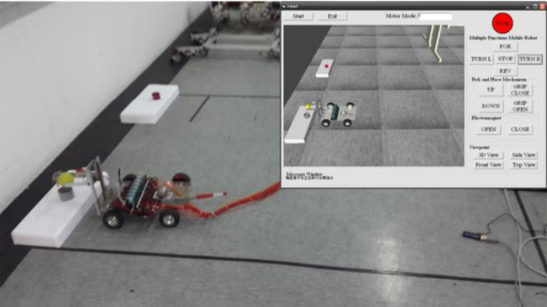Despite its potential technology, VR’s visual quality could not complete with reality’s (See Figure 2). The authors behind the proposal, Chin-Shan Chen and Ching-Wen Lui, admitted that “the aid of reality could reduce errors and quickly completing the work” (1). Switching between the VR visuals and the real visuals could cause the users headaches. Because of this, users may not immediately adapt to this new virtual method of robotics.

Figure 2: Visual Comparision between VR (top right) and Reality

**How far can Virtual Reality go?**

Passionate, determined, and creative engineers will continue to improve Virtual Reality through time. One of the most innovative VR advancements, hands-free control, aims to connect “[our] virtual world to the real world,” by allowing its users to “touch [the] virtual panel [in mid-air] to control the virtual machine tool” (Kao, Lee 2).

Motion simulation will become a stable in VR technology. It makes the use of VR much more accessible to use without the need for more required tools. This new form of control can benefit the VR Robotics experiment proposed by Chin-Shan Chen and Ching-Wen Lui, making their VR experiments as interactive as the real ones.

Figure 4: Controlling using human hands

Figure 3: Controlling using hardware

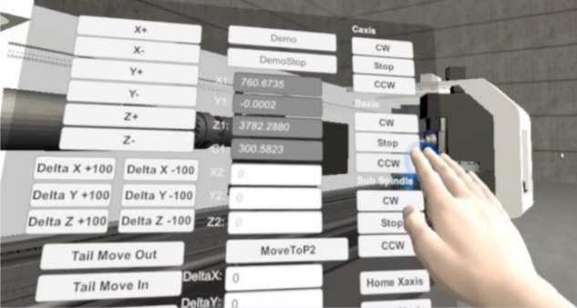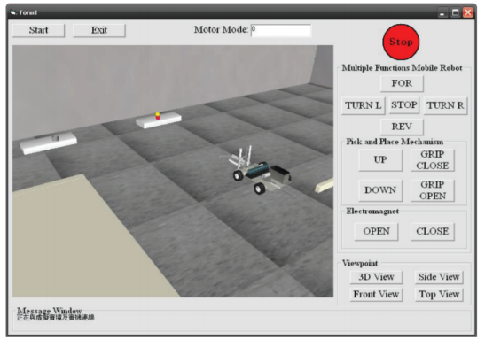

Works Cited

Chen, Gin-Shan. “Applying Virtual Reality to Remote Control of Mobile

Robot.” *Proceedings of the 2nd International Conference on Intelligent Technologies and Engineering Systems (ICITES2013)*, vol. 293, 2014, pp. 383–390. <https://www.matec-conferences.org/articles/matecconf/pdf/2017/37/matecconf_icpmmt2017_00010.pdf>

Kao, Yung-Chou. “Case Study of Virtual Reality in CNC Machine Tool Exhibition.” *MATEC*

*Web of Conferences.*, vol. 123, 2017, pp. MATEC web of conferences. , 2017, Vol.123. <https://www.matec-conferences.org/articles/matecconf/pdf/2017/37/matecconf_icpmmt2017_00004.pdf>

De França, Ana Carol Pontes, et al. “Review of Virtual Reality Technology: An Ergonomic

Approach and Current Challenges.” *Advances in Ergonomics in Design Proceedings of the AHFE 2017 International Conference on Ergonomics in Design, July 17−21, 2017, The Westin Bonaventure Hotel, Los Angeles, California, USA /*, vol. 588, 2018, pp. 52–61.

<https://link.springer.com/content/pdf/10.1007%2F978-3-319-60582-1_6.pdf>

“UNITED STATES DEPARTMENT OF LABOR.” Occupational Safety and Health Administration,

[www.osha.gov/pls/imis/accidentsearch.search](http://www.osha.gov/pls/imis/accidentsearch.search)?

Kane, Jason. “Health Costs: How the U.S. Compares With Other Countries.” PBS, Public

Broadcasting Service, 24 Mar. 2017, [www.pbs.org/newshour/rundown/health-costs-how-the-us-compares-with-other-countries/](http://www.pbs.org/newshour/rundown/health-costs-how-the-us-compares-with-other-countries/).

Evan Ackerman Posted 10 Mar 2014 | 14:51 GMT. “Immersive VR Enables Safe and Effective

Control of Big Scary Robots.” IEEE Spectrum: Technology, Engineering, and Science News, 10 Mar. 2014, [www.spectrum.ieee.org/automaton/robotics/industrial-robots/immersive-vr-enables-safe-and-effective-control-of-big-scary-robots/](http://www.spectrum.ieee.org/automaton/robotics/industrial-robots/immersive-vr-enables-safe-and-effective-control-of-big-scary-robots/)